**I. Instructions to submit updated/revised manuscript:**

1. Login to your easy chair account.

2. On the Authors page, the submissions is available.

3. Besides that, under the view tab, click on the shown mirror.

4. This will take you to the particular submission record.

5. Here, on the top right corner, “Update File” tab is available.

6. Click on that tab and submit the Updated/Revised version.

**II. Instructions for preparation of PPT:**

1. **Template for PPT:** Will be uploaded soon
2. **Online participants**
3. The presentation should not exceed 07 Minutes and not more than 15 slides.
4. The online presentations are to be prepared with AI assisted voice and the steps are the same are shown in below flowchart:

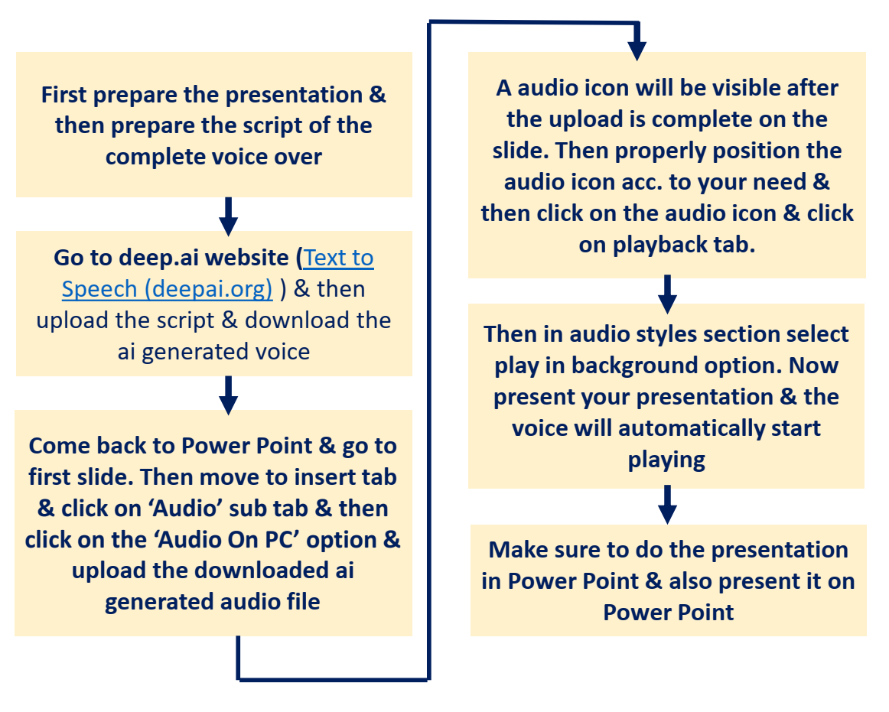

1. The PPT are to be uploaded through the google form link given below by 30.11.2024
2. Google from link for submitting online presentations: Will be updated soon.
3. **Offline participants:**
4. The presentation should not exceed 07 Minutes and not more than 15 slides.
5. Offline participants can also upload their presentation in the google form provided for online presentations. These presentations will be used as emergency backup. However, this is optional and any such PPTs uploaded should be made by using AI assisted voice as shown in the flow chart.

**III. How to reach BIT Sindri (Offline participants):**

1. **RAILWAYS:** Dhanbad Junction is the nearest Railway Station & is most important junction of the state as it is connected directly to all major cities of India, viz. Kolkata, Mumbai, Delhi, Chennai, Bangalore, Nagpur, Pune, Ranchi, Jammu, Visakhapatnam, Bhubaneshwar, Raipur, Jaipur etc. It is well connected to Howrah Junction through over a dozens of super-fast/express/local trains.
2. **AIRWAYS:** Kazi Nazrul Islam Airport (Durgapur) is around 100km from BIT Sindri. Deoghar Airport is at a distance of 133 km. Birsa Munda Airport (Ranchi) is well connected with Sindri through NH 32, road distance is 160km between two cities. Netaji Subhash Chandra Bose Airport (Kolkata) is 242 km away from Sindri.
3. **ROADWAYS:** Numerous bus/taxi services are available between Ranchi & Sindri. Ranchi is also connected by rail route (distance 167 km). It takes 3-4 hours from Ranchi to Sindri by Road.

**IV. Accommodation (Offline participants):**

Participants will make their own arrangements for travel, boarding, lodging etc. However, limited accommodation facility may be provided to the participants in hostels and guest rooms of the institute on special request. For lady participants' accommodation shall be arranged in the Girls hostels of the institute, on request. For guests, the accommodation shall be arranged by our Institute.